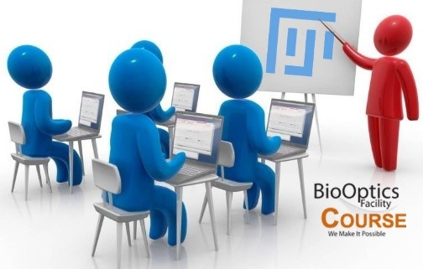
Introduction to Image Analysis with ImageJ/Fiji
Feb 9th – Friday Feb 11th 2022

This February the Biooptics facility invites you to a three-day introductory course on Image Analysis using ImageJ/Fiji. The course will be held in person (might change to an online course depending on the COVID situation on short notice)
ImageJ is an open source, community based image analysis software and a powerful tool for handling your (microscopy) image data.
In this course, we will give an overall introduction to the creation, properties and handling of digital images. We will cover a range of basic processing tools to be used within an analysis pathway for obtaining relevant biological data. A mixture of theory and hands-on exercises will enable you to use ImageJ/Fiji for your own projects. Information on hints and pitfalls will be given along the way.
This is a beginner’s course, no prior knowledge is needed.
Schedule: The course will be from Wednesday, Feb 9th , to Friday, Feb 11th. Each day it will go from 9:15 am to 6:45 pm, with a 1h break (see schedule below)
Application: Please apply by signing up in PPMS -Training request (PPMS for the BioOptics Facility) Also note that full attendance to the entire course program is expected. Attendance is limited to max 12 people.
Corona-specific rules:
2.5G+ rules apply. This means full vaccination (2 times) or recovered from covid, plus daily PCR tests. This will be monitored throughout the course, so we can ensure the safety of all participants.
What you need: A computer with a good internet connection is required. After registration you will receive a download link for the Fiji software and all course files. The basic tools we use in this course are implemented in the Fiji-version the IT is providing. Additional plugins are easily installed on PC. On Mac you might need special admin rights and therefore the help of IT.
For questions about the course, please write to biooptics-course@imp.ac.at

Wednesday Feb 9th – Friday Feb 11th 2022 9.15am – 4.45pm IMP Seminarroom E-016
Due to the current situation the seminar might switch to an online course on short notice
Unit / day | Day 1 | Day 2 | Day 3
9:15-10:00 | Welcome speech / introduction | Recap | Recap
10:15-11:00 | Image properties / Terminology | Multidimensional images | Segmentation, Binary Operations, ROIs
11:15-12:00 | Fiji: basic operations
12:00-13:15 | LUNCH | LUNCH | LUNCH
13:15-14:15 | Image Handling I: Histograms | Filters (Kernels), Denoising (Mean, Median, Gaussian) | Image measurements: Parameters, Pitfalls, Complex exercise
14:30-15:30 | Image Handling II: Bit Depth | Background correction
 |  |  | Outlook and special functions
15:45-16:45 | Image Handling III:  Look-Up Tables | Thresholding / Edge Detection

Introduction/Image handling Image Processing Image Analysis Recap, questions and answers

